2019 Drinking Gourd Chapbook Poetry Prize
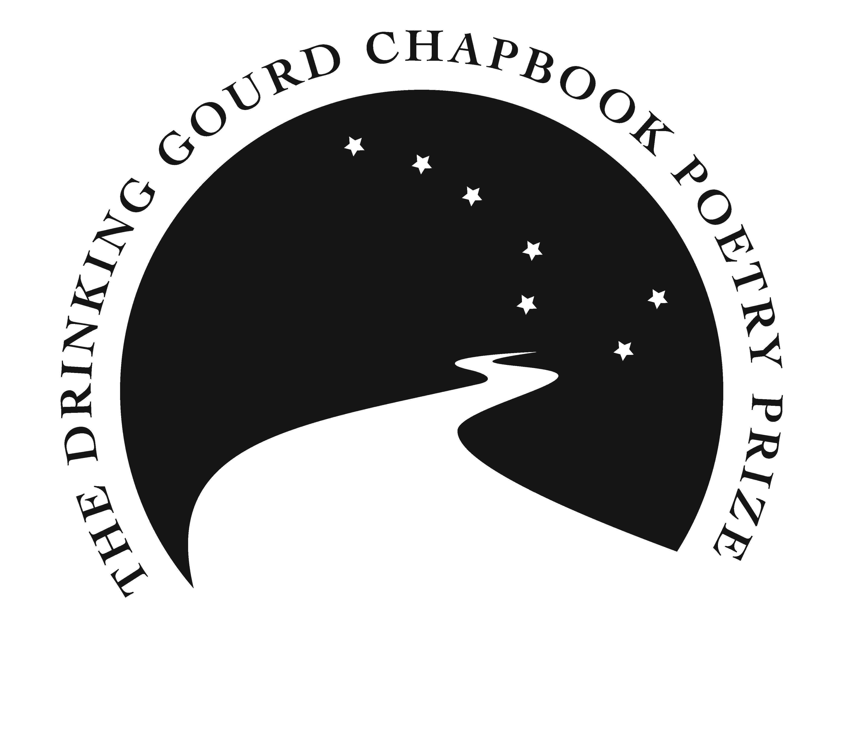
Manuscript Title: ___________________________________________
Page Length: _________________
Author Name: _________________________________
Address: _________________________________ _________________________________
Email: _________________________________
Phone: _________________________________
Brief Bio (200-word maximum): ____________________________________________
________________________________________________________________________
________________________________________________________________________
________________________________________________________________________
How did you hear about the
Drinking Gourd Chapbook Prize? ____________________________________________
________________________________________________________________________
Poetry Chapbook Checklist
Top of Form
- Single manuscript (see “Manuscript Guidelines” below)
- Attach manuscript and submission form to email separately
- Make sure that your name appears on the first page of your manuscript
Bottom of Form
Manuscript Guidelines
Manuscript must be typed single-sided with a minimum font size of 11 and 24-35 pages in length. Manuscript must include a table of contents and a list of acknowledgements of previously published poems. Post-submission revisions or corrections are not permitted. Manuscripts not adhering to submission guidelines will be discarded without notice to sender.

Entry deadline: December 31st, 2018.
Email Submission Form and Manuscript to: poetrypoeticscolloquium@gmail.com

