https://nucore.northwestern.edu/facilities
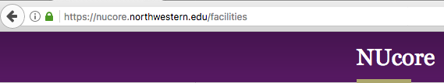

Log in

Choose RHLCCC Pathology Core (PathCore)
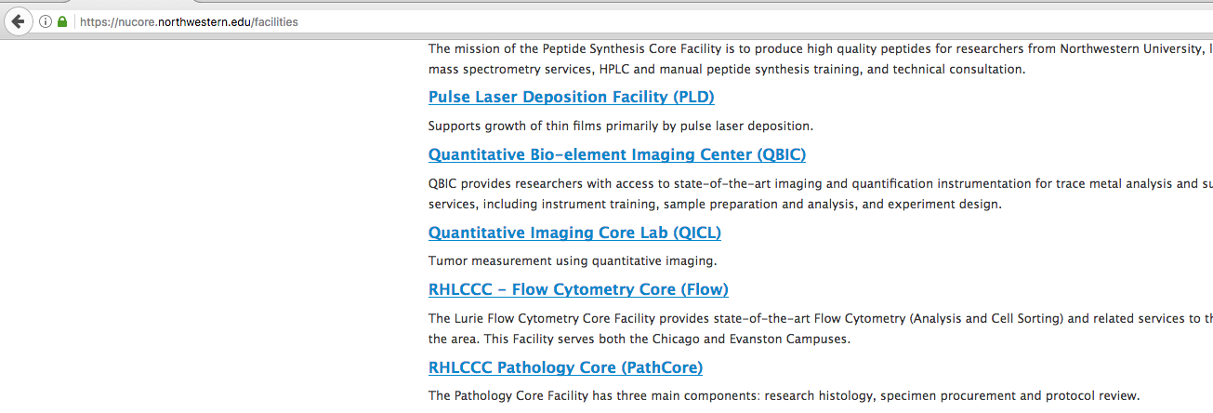

Click on Pathology Lab Services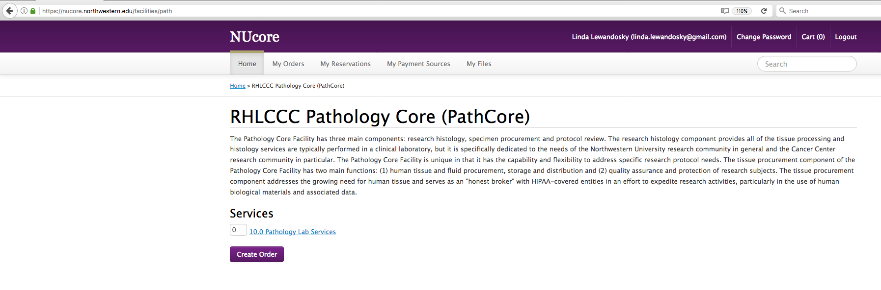

Click Add to Cart
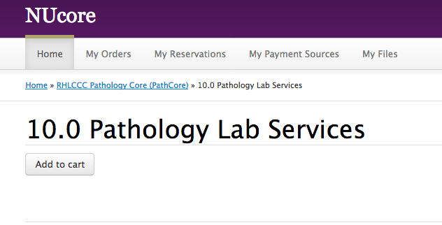

Choose Chartstring and click Continue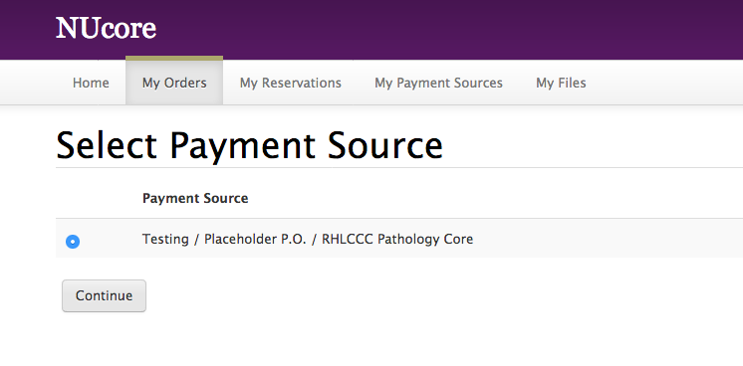

Click Purchase
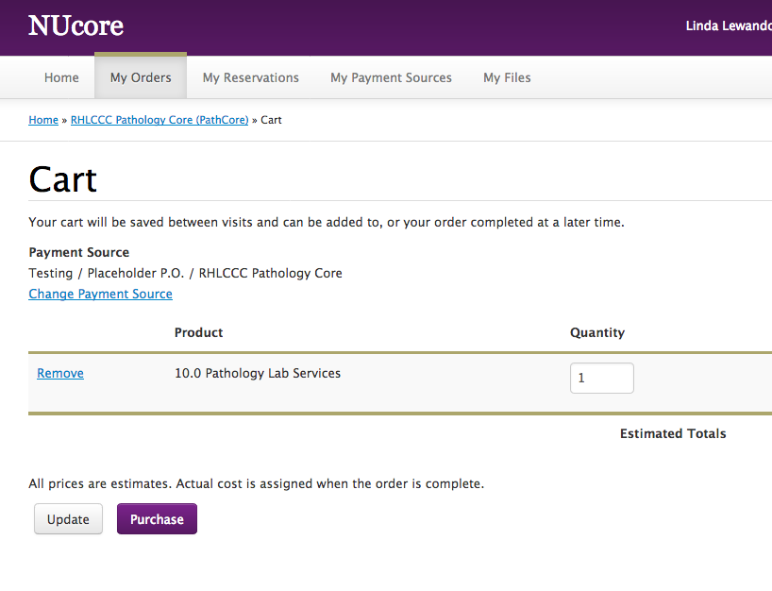

Order receipt with NUcore order number

