Instructions for Actiwatches

What is an Actiwatch?
The actiwatch is a device that records motion and light and will provide us with information about your sleep/wake patterns. There is also sensor that can detect when you are wearing the watch. If you take off the watch, it might start beeping to remind you to put it on.

Where and how do I wear it?
We would like for you to wear this watch-like device for the next 7 days and nights. Please wear it on your non-dominant arm. It is very important that you wear this at night and during the day. We not only want to know about your sleep at night, but also whether you nap and how active you are during the day. Please wear the watch tightly on your wrist. If you do not see the clock time displayed on the face of the watch (---->), you are not wearing it tight enough. The watch will start beeping to remind you to put it back on if you take it off .
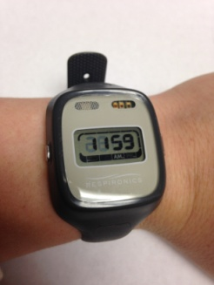
How and when do I press the event marker?
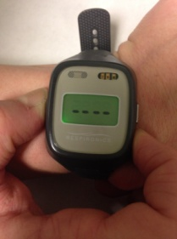
This watch also has a marker button on the left of the watch (). Press this when you turn the lights out to try to sleep at night. In the morning, push it again after you have turned the lights on to get up and start your day. This will help us determine when you went to bed ready for sleep and when you got out of bed. Press the marker and hold it for about 3 seconds, until you see 4 dots blink on the face of the watch.

Why do I need to keep a sleep diary with the watch?
Keeping a sleep diary is VERY important because it will help us interpret the information from this actiwatch. Without the sleep diary, we may not be able to analyze the information from the actiwatch.
Is the Actiwatch water resistant?
NO! Please remove this when you are bathing or if you will be swimming. Also, please remove this if you are engaging in physical activity and feel that it might get damaged.
Questions:
If you have any questions about the actiwatch, please contact the study coordinator: Megan 312-942-0549

